The Ebb and Flow of Gaming
By Arden Hoehn-Saric and Michael Lindsay
Abstract
The aim of our research is to gather purchasing information about Steam games, and use this information to estimate the most successful month to release a game in. We chose to focus on Steam games, as they are the most accessible to a wide audience and have publicly available sales numbers. To prevent bias, we aimed to combine multiple datasets using different methods of data gathering. The main challenges in our research came from understanding how to combine multiple datasets measuring subtly different things. We were forced to convert values in one dataset to the final dataset but performing a linear transformation of the data. After combining the datasets, we were able to sort our games by the month they were released in and extract engagement numbers. Using these numbers, we found that the most popular games released in February, June, and December.
Introduction
In a highly modernized society, video games have taken a more prominent role in leisure activities, as they create personalized challenge without the need to involve other people. With this increased cultural prominence, there is a severe lack of useful information on the sales of video games. Physical stores are required to report the sales of everything they sell, including video games, but online marketplaces such as the Epic Games Store or PlayStation Network have no such requirements. As such, this report of information from an easier target - the steam store, which provides developers with API keys giving some insight into sales - provides a vital framework for cataloging these sales. By analyzing the trends of video game sales year by year, this study highlights important areas to focus on for future analysis. We obtained our data from three different sources, to represent the patchwork state of data about video game sales. These were gamalytic.com, an easily sortable database, steamspy.com, an API project and database, and direct webscraping, providing information without having to rely on developer keys. The approach we took was to first make a separate database for each of our sources. Then, we created a formula to get a combined score for each database, which would represent the interest in that game and be comparable to the other databases. These databases were then combined to make a singular database with the game name, combined score, and price. Using this combined database, we found that games were most popular when released in February, June, and December. Games released in July were the least popular, and games released in November had noticeably lower prices, though this drop in price did not result in a change in popularity. Additionally, a heat map of price and combined score did not find a noticeable relationship between the two variables. When judging the veracity of future data, especially from unreliable sources like a company, these trends should be taken into account.
Methods
We have three different data sources, the Gamealytics data, the SteamSpy database, and the webscraping dataset. The process of turning our data sources into actionable data can be seen in Figure 1. First we collected the data from each individual source into a CSV using various methods. The Gamealytics and SteamSpy data was gathered by direct download of CSVs, while the webscraping data was gathered by adapting an online guide which can be found in our references. Then, this data was filtered to isolate the most important features of the dataset. For each dataset, these features were used to create a score for each game, primarily based on the number of users. These scores were combined into one dataset, and this combined dataset was used to find the interest games over time, as well as other graphs seen in the Results section.

Figure 1: Overall workflow
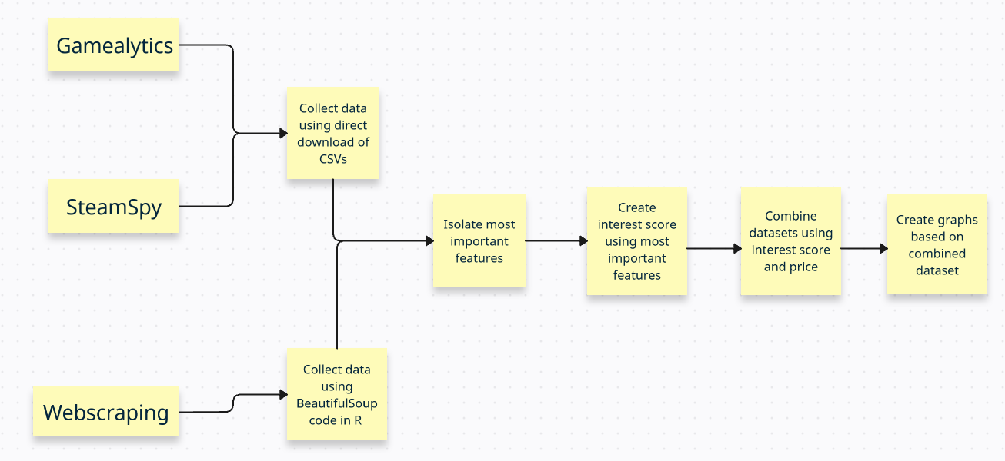
The Gamalytics dataset includes 500 games from each year between 2020 and 2024. Each of these games are marked by a unique steamID, which is assigned by Steam. The data for each game includes the name of the game, whether the game is released or not, the first release date, whether the game is in early access or fully released, the number of copies the game has sold, the price, the total revenue, the Steam review score, the class of the publisher, a list of publishers, a list of developers, a link to the game’s header image, and a link to the game’s Steam storefront page. The list of publisher classes include Hobbyist (publishers that have made less than 10k on steam), Indie (independent publishing that has made less than 50 million on Steam), AA (a minor but well known publisher, having released moderately popular games in the past making less than 500 million), and AAA (a major publisher, having released many majorly popular games in the past). This dataset arrived as a list of 50 smaller CSV files, which were combined to make one file. Before combining all the sources, we decided to filter out game information to the most important data. This included the game name, as a way to combine games from different datasets, the first release date, to understand the trends of game sales by month, and the copies sold, price, revenue, and review score, to create a measure of consumer interest for the game. To simplify the data, we decided not to include data about the developers or publishers, as we already had a way to value success and didn’t need to use this information to estimate the success of a game.
The SteamSpy dataset includes a total of 5000 games released from the years 2015 to 2021, downloaded as CSV files directly from the SteamSpy website. For each game, the data sourced by SteamSpy included its overall ranking from in its respective release year, the title of the game, the release date (in Month Day, Year format), the price of the game on release, the average metascore of the game from ratio of positive reviews on steam, the range of users that own the game (e.g. 50,000,000 - 100,000,000), the median playtime on steam, the primary developer, and the publisher. Of these statistics, release date, price, and number of owners were used for primary data analysis.
The webscraping dataset includes 5000 games directly collected from Steam’s search function. Each of these games are marked by an app_name, which is the title of the game. The data for each game includes the name of the game, a list of features, a list of tags, the metascore, the number of reviews, the number of copies the game has sold, the price, the total revenue, the Steam review score, the percent of reviews that were positive, the release date, the price, a list of publishers, and a list of developers. The list of features include properties about the game, such as if the game is single player or multi player, or if the game supports Steam achievements. The list of tags include information about the type of game, such as City Builder or Role Playing Game. The metascore is a compilation of official game reviews, created by an external company. Most games do not have enough official reviews to be given a metascore. This dataset was created using modifications from an online guide to webscraping Steam. The most important data of this dataset included the game name, as a way to combine games from different datasets, the release date, to understand the trends of game sales by month, and the number of reviews, percentage of positive reviews, and price, to create a measure of consumer interest for the game. We decided not to include the metascore of the games, as only about 20% of the games included the metascore, and we wanted to create a consistent metric to judge the games.
In order to combine these three datasets into one, consistent set of data, a python program using the numpy, pandas, and builtin csv libraries was used. The python program made use of two dictionaries to store the data about each game, one of which was designated for free to play (F2P) games with the other containing only priced (>$0.00) games. For each csv file, the program iterated through every line and performed a series of checks and adaptations to ensure the final dataset would be uniform despite the differences in initial gathering methodology. Any game that did not have its price, player count, or release month reported in the original dataset was excluded from the final set, and formatting of each metric was standardized as follows: release month was stored as a three letter abbreviation (e.g Jan, Feb, etc), player count was recorded directly if reported, taken the average of if reported as a range, and was estimated by an average of 70 users per review if player count was not available but review count was, and price was converted to a float data type across the board, even if reported as “Free”. All data in the dictionaries was then converted into two pandas DataFrames, one for f2p games and one for priced games, each sorted by release month. If the number of games in one month’s column was less than others, the remaining space was filled with null values that would be ignored in the final analysis.

Results and Discussion
To visualize the relationship between the month a game released in and the amount of interest in the game, we decided to make a bar graph sorting the games into months and displaying the estimated average sales of games in that month. This visualization can be seen in Figure 2. As seen in the scale on the right, the greener a game’s bar is, the more popular games in that month were.

Figure 2: Relationship between release month and estimated number of players
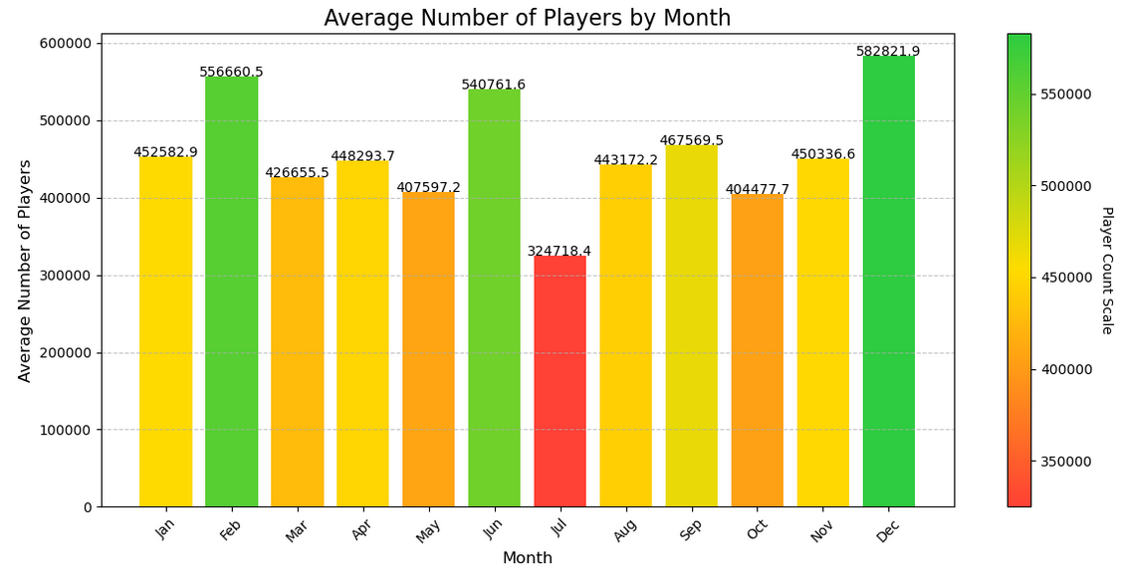
We decided to further investigate this data by mapping the relationship between the release month and the average price of a game. This visualization can be seen in Figure 3. Note that the color of each bar represents the average number of players in that month, as seen in Figure 2. This method allows us to identify trends between the number of players in a month and the average price of a game in that month.

Figure 3: Relationship between release month and average price of games in that month
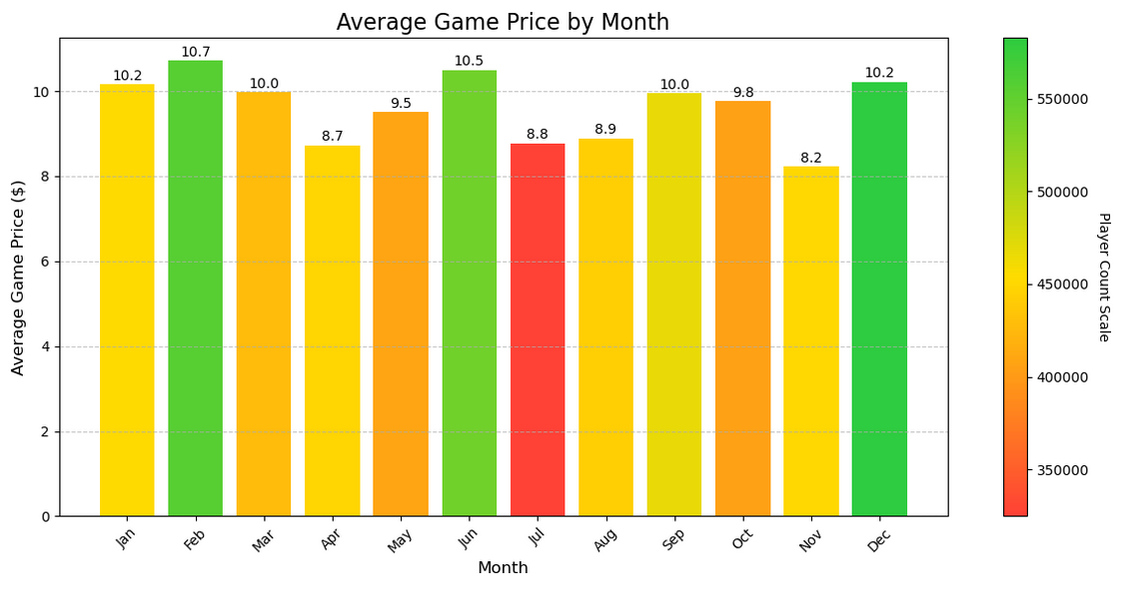
In order to determine whether there was any statistically significant correlation between the three main factors measured, heatmap was created displaying the linear correlation values between features. The correlation values seen in Figure 4 can range from -1 to 1, with the increase in magnitude of the correlation value represented on the purple to yellow scale and negative values being interpreted as a negative correlation.

Figure 4: Linear correlation heatmap between price, release month, and user count
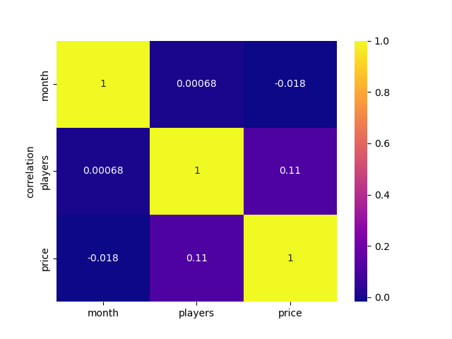
Using Figure 2 to observe the relationship between a game’s release month and its number of sales, we see that games released in February, June, and December are the most populated with players, with all of these months having 17% or more players above the average. This makes some sense, as many people tend to buy gifts or treat themselves during the December holidays, meaning that we can expect luxury gifts such as video games to rise in demand. A spike in June also makes sense, as the start of summer vacation means that a major video game demographic - students - will have more free time to spend on games and other leisure activities. However, a spike in video game popularity during February is unexpected, as I can’t think of any major events during that month that would cause this surge of interest. Perhaps Valentine's day is becoming more video game themed in recent years?
July seems to show a major dip in video game sales, showing a 30% drop in players compared to the average player count. Perhaps there’s a sort of crash after the start of summer vacation, where students generally have most of the games they want? Looking at Figure 3, we see that the average price of games in July is $1.70 lower than the previous month of June. This is low, but not meaningfully lower than all other months, with April and November having even lower average prices. The most interesting thing about graphing the average price of games over time is that there tend to be peaks around popular months. For example, February is a popular month, and the average price of games in that month is at least $0.50 higher than the surrounding months of January and March. It makes sense that publishers would price their games higher during popular months, as that tactic increases their profits. However, this doesn’t explain the peak in September and October, where games are more expensive than the surrounding months, but not noticeably more popular. Perhaps it’s common wisdom that September and October are popular months, so publishers charge more for games even when the data shows otherwise?
The linear correlation between the values of price, release month, and player count can be seen in Figure 4. Overall, the correlation between price and player count is seen to be the largest in magnitude, with a statistically significant correlation value of 0.11. Being a positive correlation value, the data suggests that games with high prices tend to have higher player counts across the dataset. This may be a result of AAA, high production value games having the largest audiences and overall customer reach despite the recent popularity of F2P games. The correlation between release month and player count is much smaller than expected when compared to the data found in Figure 2, as it seems to predict a lack of correlation between the metrics. This is likely due to the limitations of using a linear correlation algorithm, however, as monthly variance in player count does not follow an increasing or decreasing trend over time. As seen in Figure 2, certain months demonstrate a clear difference in overall player count, but this is not properly captured through linear correlation.
Conclusion
This analysis shows a trend of video game interest in February, June and December, and a lack of interest in July. Additionally, it shows that prices tend to peak in June and December, and are noticeably lower in November. This can be used as a tool for evaluating the trustworthiness of other datasets. These trends should be seen in sales data released by companies, especially for online storefronts where unbiased observation is lacking. If these trends are not observed, further analysis should be done on why those trends do not exist. When doing future research with the Steam dataset, we would like to identify relationships between the popularity of video games and the popularity of other luxury goods. This would allow us to further isolate trends specific to video games, rather than the luxury world at large.
Roles
Arden Hoehn-Saric gathered the Gamealytics and webscraping data, while Michael Lindsay gathered the SteamSpy data. This included turning the given data into a python readable list and cleaning the data. Once all our data is cleaned and Python readable, Michael was responsible for combining the data into one CSV file, including creating an interest score for each dataset. Arden was responsible for the analysis of video game sales and interest over time, including making visualizations to highlight trends in the data. Michael was responsible for analyzing the correlation between sales and price, including a heatmap relating the two variables. Both Michael and Arden were responsible for making a report explaining their research.

References
Gamealytics CSV Dataset, accessed 11/28/2025. Author unknown. https://gamalytic.com/
SteamSpy CSV Dataset, accessed 11/28/2025. Sergey Galyonkin. https://steamspy.com
Steam web scraping and analysis, accessed 11/28/2025. Author unknown. https://ybgodoy.github.io/

